CASE STUDY ON SUSTAINABILITY STRATEGIES, ESG AND DESIGN WORK AT PLASTIA NOVÉ VESELÍ
“How might we make the world a more sustainable place?”

ESG Strategies theory
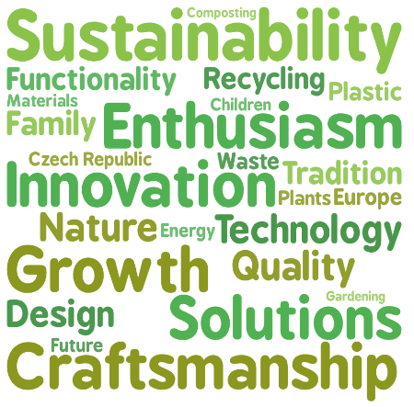
ESG stands for environmental, social and governance. It is a way of looking at how a company behaves towards the environment, people and society, and how responsibly it is managed.

A simple way to understand the goal of an ESG strategy is this question:
How might we make the world a more sustainable place while still running a successful company?

Do you agree with this statement?
“What is economical must be ecological and vice versa, what is ecological must be economical.”
Prof. Ing. Vladimír Jeníček, DrSc. (FMV VŠE Praha)

About Plastia Nové Veselí
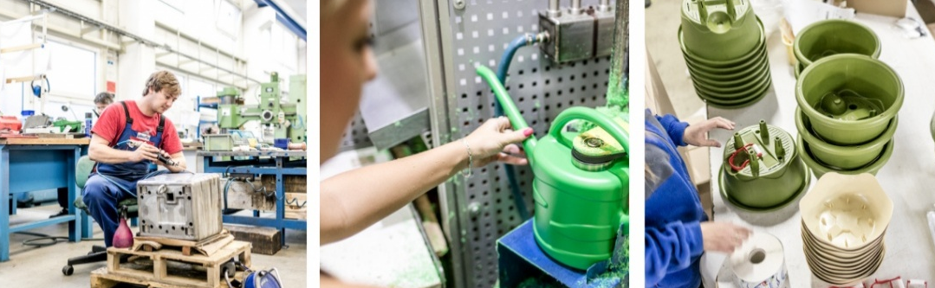
Plastia is a Czech family company based in Nové Veselí, Czech Republic. It was founded in 1993 and focuses mainly on products for growing plants, gardening, composting and bringing nature closer to everyday life. Its products include flowerpots, self-watering containers, composters, bird feeders, watering accessories and newer products connected with home growing and circular design. Plastia exports its products to more than 56 countries. This means that the company is local in production, but international in its market. It also means that sustainability decisions made in Nové Veselí can influence customers far beyond the Czech Republic. The company presents perfect design, quality and functionality as central values. This is important because sustainable products only work if people actually want to use them. Good design can therefore support sustainability.

ESG Strategy in Practice: Three Simple Examples
The following examples show how ESG can be visible in real products:

Example 1: Worm Farm Urbalive
From scraps to soil, start the cycle at home.

Why should you care about bio-waste?
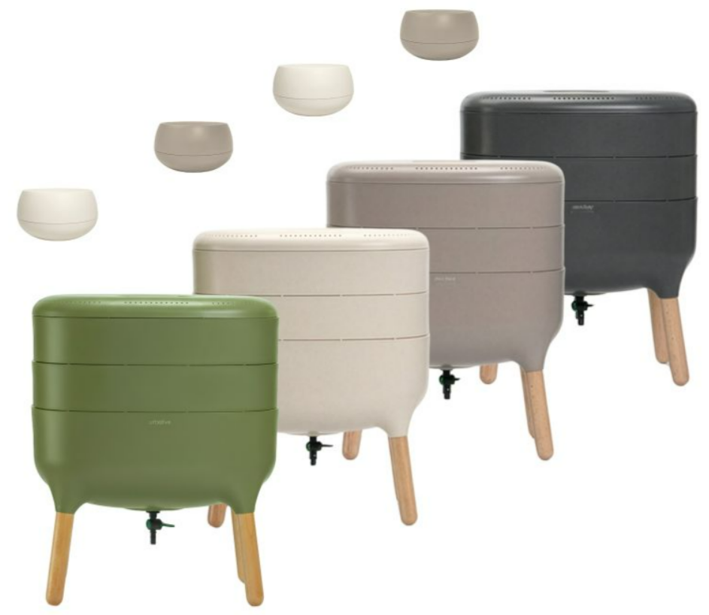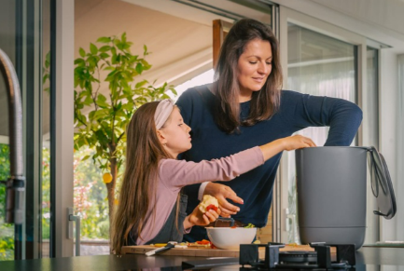
The Urbalive worm farm is a designer home composter for apartments. Plastia designed it to use red wriggler earthworms to turn kitchen biowaste into vermicompost and worm tea (liquid fertilizer), providing both solid and liquid natural fertilizer. The product is suitable for indoor use and, when used correctly, composting takes place without odour.
The vermicomposter is also an example of how design can remove barriers. Many people may think that composting belongs only in a garden. A well-designed indoor composter makes composting possible even in a flat or a small classroom.
The design was created by Czech designer Jiří Pelcl. The product received international design awards, including Red Dot Design Award and Good Design Award.

Example 2: Urbalive Microgreens and Regrow
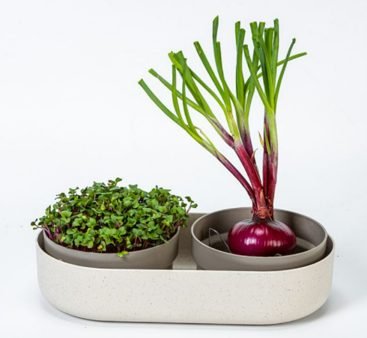
The second example is connected with home growing. Plastia’s Urbalive growing products for microgreens and regrowing help people produce small fresh plants at home. Microgreens are young edible plants that can be harvested after only a few days, depending on the type of seed.
This product line connects sustainability with self-sufficiency. People can grow fresh greens in their kitchen even during winter. They do not need a garden, long transport chains or large equipment. The product therefore supports a small but practical change in behaviour: producing part of one’s food directly at home.
The microgreens product also uses an interesting material approach. Its final appearance is created by combining the main material with 10% coffee grounds, which gives the product a natural-looking texture and colour. This creates a visible story of material reuse.

Example 3: REcap Reusable Cup
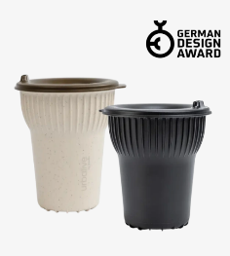
The REcap is a reusable cup designed by Ladislav Škoda. It is coloured with real coffee grounds, which are processed into a dye for plastic. This is an example of cascade recycling: a material that would usually be considered waste receives another use before the end of its life.
This product is especially useful for explaining the link between ecology and economics. A reusable cup can reduce the number of disposable cups. At the same time, it can also reduce costs for venues and event organisers when it is used many times. Plastia communicates that one cup can replace many disposable cups over repeated washing cycles.
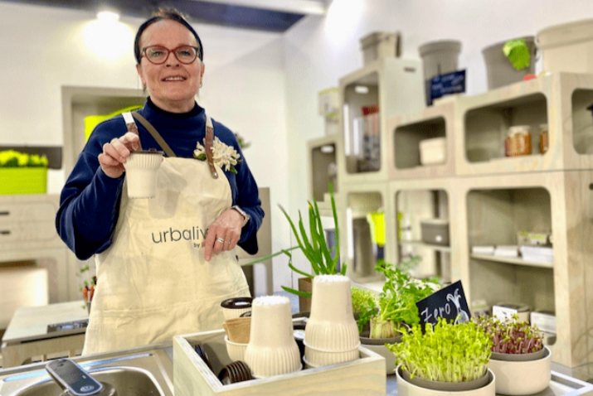

ESG at Plastia Overall
The three product examples show the extrospective part of ESG: products that help customers behave more sustainably. However, ESG also includes what happens inside the company. Plastia’s approach can be organised into the three ESG areas: Environmental, Social and Governance.

Environmental: How Plastia Works with Nature and Resources
The environmental part of ESG focuses on materials, waste, energy, product life and impact on ecosystems.

Recycled & recyclable
Waste from production is crushed and processed again and the company also works with recycled plastic where it makes sense. Durability is also important: for exterior parts exposed to sun, rain and temperature changes, the company has to choose materials carefully so that products remain durable.

Long product life
Plastia emphasises durable design and quality processing. Stronger load-bearing parts, modular accessories and easy disassembly help products last longer. Products are tested, improved and tested again. This matters because the most sustainable product is often the one that does not need to be replaced quickly.

Energy savings & Solar energy
Solar energy powers our machines. Clean production means a clean story you can tell your customers. In times when everyone asks about product carbon footprint, you have a clear answer. The products are made in harmony with nature—and that's today's competitive advantage.

Rice bran, wine scraps and coffee grounds
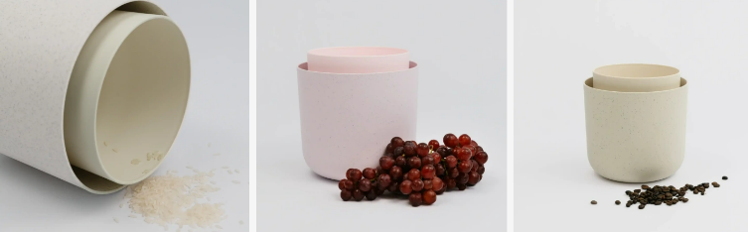
Plastia and Urbalive experiment with adding natural by-products into plastic materials, such as EU rice bran, wine scraps and coffee grounds. These materials would normally be treated as waste or low-value leftovers, but they can be given a new function in product design. For example, coffee grounds can be used as a natural colourant, giving products a distinctive texture and colour while reducing the need for purely synthetic colouring.

Cascade recycling of coffee beans
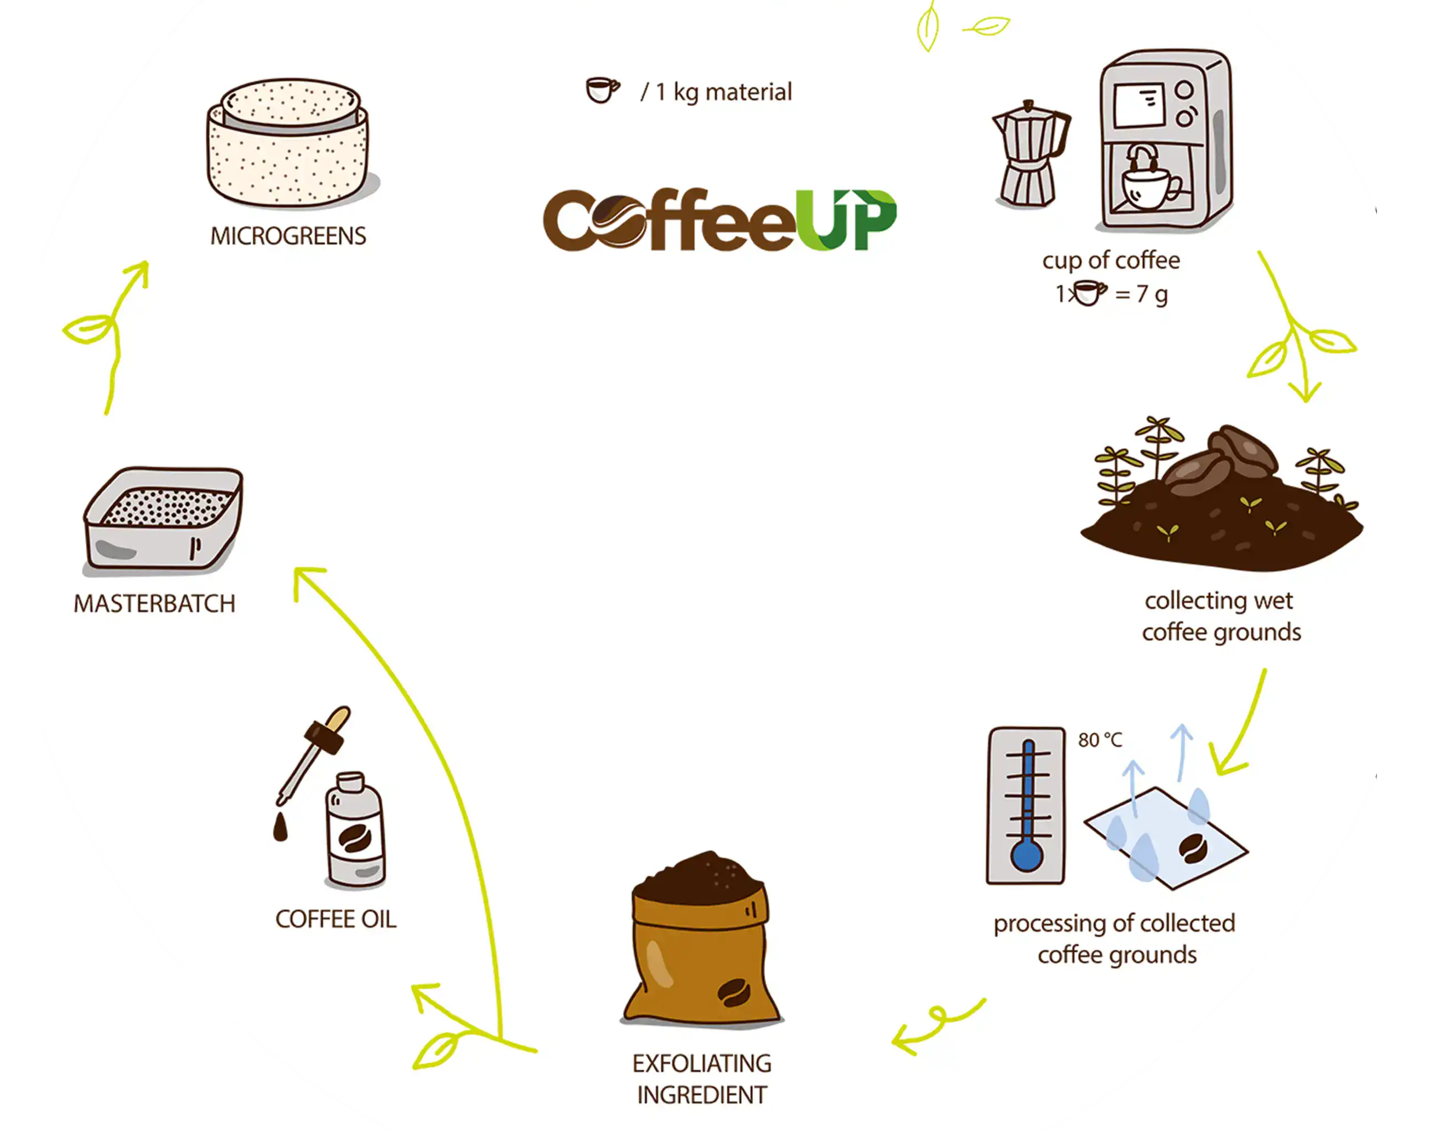

PLASTIC IN THE SERVICE OF NATURE
„We also consider how to best use the various types of plastic. We combine plastics with natural materials whenever we can. Inner parts and products that are less exposed to the weather and sunlight are made from recycled plastic whenever possible. Sunlight is major enemy for plastics, so the outer walls of our containers are made of original materials. We carefully monitor our product range. We only make things which MAKE SENSE. The individual materials are clearly marked using recycling symbols. This makes it easy to recycle the individual parts of a product after the end of its service life. The individual materials can be easily taken apart to make recycling even easier. Moreover, no piece of plastic goes to waste in our manufacturing process. Manufacturing waste is simply crushed and reprocessed. We are taking small but steady steps towards a circular economy.“

„Otoč květináč“ | Return and reuse of flowerpots
The project Otoč květináč is a practical example of circular economy. Customers can bring old plastic flowerpots and planters to collection boxes in partner stores. The collected items are sorted. Functional pieces can be donated to places where they can still be useful, such as schools, social institutions or reuse centres. Broken pieces can be crushed and used to make new flowerpots, or sent for proper recycling.
This project is important because it goes beyond normal production. It tries to influence what happens after the product has been used. In a circular economy, companies think not only about selling a product, but also about what happens at the end of its first life.
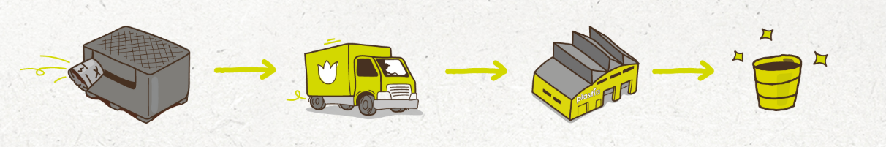

Social: How Plastia Works with People and Communities
The social part of ESG focuses on employees, customers, education, community and cooperation.

Local employment and production
Plastia produces in Nové Veselí and works with employees in one production location. Local production supports regional employment and keeps know-how in the area.

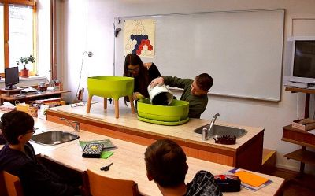
Education through products
Products such as vermicomposters, microgreens kits and bird feeders are not only objects. They can become educational tools. A student using a vermicomposter can learn about decomposition, soil, microorganisms, worms, food waste and nutrient cycles. A class observing birds at a feeder can learn about biodiversity, species recognition and seasonal behaviour.

Vermicomposters in schools
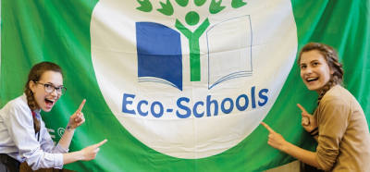
The project „Žížaláci ve vermikompostéru“ showed how a composter can become part of school life. In the 2017/18 school year, Plastia cooperated with the Ekoškola programme of the educational centre Tereza. Fifteen schools were involved in a year-long project. The schools received vermicomposters and methodological materials, and pupils learned through observation, care and problem-solving.

Cooperation with experts and organisations
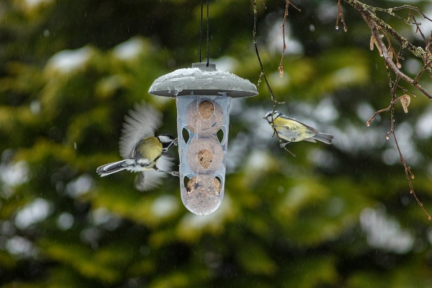
Plastia cooperates with growers, professional gardeners, florists, designers and, in the case of bird products, also with ornithology-related partners. Cooperation with experts improves product quality and helps prevent superficial solutions.

Citizen-science activities: „Ptačí hodinka“ (The Bird Hour)
Ptačí hodinka is a bird-counting project organised in the Czech Republic by the Czech Society for Ornithology. This connects product use with public education and nature observation.

Support for families, mothers, children, hospitals
Plastia financially supports Mateřská škola Nové Veselí, Mateřské centrum Zvoneček Havlíčkův Brod and Mateřské centrum Boskovice. These examples show support for local education, childcare and family communities.
The company also supports Nedoklubko, an association helping premature babies and their parents. In this case, Plastia contributes not only financially, but also through the direct involvement of employees in the association’s activities.
Another example is support for the Neonatology Department of University Hospital Brno, specifically the department for premature babies. Plastia helped by purchasing specialised equipment in cooperation with DN Formed Brno.

Partnership with Its Own Employees

Governance: How Plastia Makes Responsible Decisions
Governance is often the least visible part of ESG, but it is very important. It means how decisions are made, how quality is controlled, and how the company behaves as a business partner.

Local control of development and production
Because development, testing and production are close to each other in Nové Veselí, Plastia can control the process more directly. Problems can be noticed and solved faster. Designers and production specialists can work together.

Supplier and partner selection
The company values strong local partnerships and carefully selects suppliers, with preference for Czech suppliers where possible. Local and reliable partnerships can reduce risks, shorten communication chains and support regional economic resilience.

Compliance and regulation
The REcap reusable cup shows how governance is connected with legal and market requirements. Companies must react to regulations on packaging and single-use products. Instead of seeing regulation only as a problem, Plastia uses it as a reason for innovation.

Employee Partnership and Responsible Management

Plastia Nove Veselí
Plastia’s case shows that esg can be practical. It is not only a report, slogan or advertisement. It can influence what a company produces, how it produces, how it works with customers and what projects it supports.

Sources Used
Plastia, “About us,” Plastia, https://www.plastia.eu/en/about-us (accessed May 7, 2026).
Plastia, “Warm farm Urbalive,” Plastia, https://www.plastia.eu/en/worm-farm-urbalive (accessed May 7, 2026).
Plastia, “Bio waste management,“ Urbalive , https://www.plastia.eu/vermikomposter-urbalive (accessed May 7, 2026).
Plastia, „Microgreens and Regrow ivory,“ Plastia, https://www.plastia.eu/en/microgreens-and-regrow-ivory (accessed May 7, 2026).
Plastia, “Urbalive,” Plastia, https://www.plastia.eu/urbalive (accessed May 7, 2026).
Plastia, “Urbalive,” Sustainability that grows with you, https://www.urbalive.eu/sustainability (accessed May 7, 2026).
Plastia, “REcap,” Urbalive, https://www.urbalive.eu/products/recap (accessed May 7, 2026).
Plastia, “Sustainability,” Urbalive, https://www.urbalive.eu/sustainability (accessed May 7, 2026).
Plastia, “Vermikompostéry do škol,” Plastia, https://www.plastia.eu/vermikompostery-do-skol?lng_code=cs (accessed May 7, 2026).
Plastia, “Ptačí hodinka,” Plastia, https://www.plastia.eu/ptaci-hodinka (accessed May 7, 2026).
Plastia, “Otoč květináč,” Otoč květináč, https://www.otockvetinac.cz/ (accessed May 7, 2026).
Plastia, “Pomáháme,” Plastia, https://www.plastia.eu/pomahame (accessed May 7, 2026).
Consultations with: Lenka Novotná, Plastia Nové Veselí and Ing. Václav Karban, Plastia Nové Veselí, internal company documents

Created as part of the Erasmus+ KA2 project titled Three Voices in Green.
Co-funded by the European Union. Views and opinions expressed are however those of the author(s) only and do not necessarily reflect those of the European Union or the European Education and Culture Executive Agency (EACEA). Neither the European Union nor EACEA can be held responsible for them. More information about the Erasmus+ Programme: https://erasmus-plus.ec.europa.eu/ and https://www.dzs.cz/program/erasmus.

